Team01-Hampod 2

To
Wayne Padgett, Rob Santello
Dr. Miller, Rose-Hulman Institute of Technology

From
Team 01
Salik Ahmad, Andrew Mills, Michael Trinh, Ethan Townsend

Version 1.0
4/22/2025

Executive Summary
The Hampod 2 project aims to develop an upgraded and fully functional version of the original Hampod system for blind and visually impaired operators, allowing thousands to easily interface with their Ham radios. The project deliverables will include the fully functional and upgraded Hampod system that supports frequency tuning, USB output, multiple radio types, and a low latency audio feedback system, along with a user manual that provides simple hardware and software setup instructions. Additionally, human testing reports will be provided to assess usability and ease of setup.
To accomplish this goal and meet the deliverables, there will be several milestones developed to guide the process. First, it will be important to conduct research on the hardware and software behind ham radios, allowing us to, secondly, do hardware and software redesigns on the former team’s system. The following milestones after the research and redesigns are combining the hardware and software system designs into a full architecture and prototype, conducting internal testing to determine errors and improvements, and finalizing a prototype based on the test results. This will help with the production of a functioning HAMPOD system with a low latency audio feedback system. Lastly, user testing and the implementation of the feedback from user testing will lead to the delivery of the final product that meets all necessary features, complete with all documentation.

Table of Contents
1. Introduction and Project Overview 4
1.1. Motivation and Context 4
1.2. Deliverables 4
1.3. Stakeholders, Features, and Metrics 5
1.4. Achievements with Respect to Deliverables & Features 7
2. Accomplishments 8
2.1. Description of the Solution 8
2.1.1. Speaker Output & Text-to-Speech 9
2.1.2. Radio Control and Communication 10
2.1.3. Internal Circuitry and PCB Design 15
2.2. Verification of Requirements 21
2.2.1. Feature: Robust 24
2.2.2. Feature: User-Friendly 24
2.2.3. Feature: Configurable 25
2.2.4. Feature: Documented 25
2.2.5. Feature: Affordable 25
2.2.6. Feature: Manufacturable 26
3. Project Plan and Timeline 27
3.1. Original Timeline Description 27
3.2. Final Timeline and Reflection 30
4. Budget 33
4.1. Labor Costs 33
4.2. Costs of Materials 34
5. Recommendations 38
5.1. Quality Assessment 38
5.2. Future Directions 39
6. Going Further Material 41
6.1. Standards 41
6.1.1. USB 2.0 41
6.1.2. IEEE 802.3 (Ethernet) 41
6.2. Impacts of the Project on Broader Issues 41
6.2.1. Public Health, Welfare, and Safety 41
6.2.2. Global Issues 41
6.2.3. Societal Issues 41
6.2.4. Economic Issues 42
6.2.5. Environmental Issues 42
6.3. System Failure Mode Analysis 43
6.3.1 Component Failure Mode: Power Surge at Power Jack 43
6.3.2 User Error Failure Mode: Selecting the Wrong Radio 43
7. Bibliography 44

Please indicate a single page number for an example of each of the following types of figures that explains an important part of your project. If that type of diagram does not exist in your project, please put N/A for the page number.

Circuit Schematic (either analog or digital such as microcontroller):____19_______

User interface or other user experience design:_____15_______

Flow chart/UML diagram/or other similar diagram of code function or structure:_____11_______

Logic diagram such as FPGA architecture: _____N/A________

Mechanical diagram such as CAD drawing: ____N/A__________

Other type of diagram such as CST diagram, PCB design, etc.: ___17________

Introduction and Project Overview

Motivation and Context
The clients for this project are Dr. Wayne Padgett and Mr. Rob Santello. The HAMPOD project was initiated to make amateur radio operations accessible to blind and visually impaired users. The device was originally connected to radios and provided audio feedback for control parameters, such as frequency and modulation. However, the original device’s software had become outdated due to its reliance on assembly language for the PIC processor. The original device’s hardware has also become obsolete, making it harder to maintain and update.
The previous team made progress on an updated version but encountered issues with software functionality and hardware fit. The updated system used hardware like the NanoPi paired with Hamlib, a software library that facilitates control of different radios. A software synthesizer was also employed to provide text-to-speech audio for the user. One key focus will be enhancing the speed and accuracy of the audio feedback. They had issues with the integration of the Hamlib software library and its interaction with the hardware proved to be buggy. The source of the bugs found was not identified by the previous team. The updated software architecture was not simple enough for a visually impaired user to operate without reading detailed instructions. They experimented with WAV files and text-to-speech synthesizers for audio feedback, but their final version still had latency issues and requires improvement. The software’s robustness was a key issue, and the client found it difficult to setup the device straight out of the box. Also, the version of Linux used in the previous design was unstable.
The client and stakeholders have expressed the need for a modular, adaptable, and user-friendly version of the HAMPOD. The aim is to create an updated version of the HAMPOD device that allows seamless operation for visually impaired users, supporting new radios that use USB interfaces. The goal is to build a robust system that integrates well with current hardware and software while providing a smooth user experience.

Deliverables
- Functioning HAMPOD system
  - Support frequency tuning
  - Support USB out
  - Support several different types of radio
- User manual that will have step-by-step instructions on the hardware and software setup
  - Instructions must be simple and clear enough for users to setup straight out of the box
- Audio feedback system with low latency
  - Should allow user to quickly receive audible information on what frequency they’re at with minimal delay
- Human usability
  - Report on human testing of attempts of at least 3 ham radio operators to make a frequency change on the connected radio via the Hampod while blindfolded.
- Ease of setup
  - Report on human testing of attempts of at least 3 ham radio operators (no blindfold required) to connect to a radio, and configure it to work with the Hampod following the User Set Up Manual.

Stakeholders, Features, and Metrics
Table 1: Stakeholders and Their Associated Features
Stakeholder Name | Associated Features | Describe the stakeholders with respect to the Associated Features
Visually Impaired Ham Radio Users | User-Friendly  Robust  Documented  Configurable  Affordable | The Ham Radio users, specifically visually impaired users, the primary users of the Hampod and our primary stakeholder. It is vital for them that the Hampod is very user-friendly. It must have a simple and intuitive UI. Furthermore, it must have simple packaging and connect ability to a Ham radio. This means that there also needs to be sufficient documentation to help guide them on the necessary steps to set up the Hampod and make any necessary updates depending on what radio they are using. Furthermore, it is important they have robust communication. They cannot have their Hampod crashing because of their radio model or a slight inconvenience. The Hampod needs to work consistently and connect well to the radio every time. Lastly, it is important for users that the Hampod is configurable for the hardware it can work with. Different users have a variety of different radio hardware, and thus, the Hampod must be able to work with those radios. Lastly, the users would want the Hampod to be affordable, hopefully in the low hundreds’ maximum, so that it is reasonable for an individual to purchase.
Clients (Mr. Santello and Dr. Padgett) | User-friendly  Robust  Documented  Configurable  Affordable | The clients who tasked us with the project explicitly expressed to us what improvements are needed for the Hampod. Specifically, Mr. Santello, the creator of the Hampod, has described how he wants it to be very user-friendly and intuitive for visually impaired users to use. He wants robust communication that consistently works as well as configurability with the Hampod able to work with numerous radios. The clients expressed how currently the documentation surrounding the work done is very poor and needs to be sufficiently improved, so that a new user can easily utilize the Hampod. The clients also directly expressed that they want the price to be under $300.
Hampod Manufacturers | Documented  Affordable  Manufacturable | Once the Hampod product is finalized, there may be manufacturers who would like to produce and sell the Hampods. These manufacturers need the product to be well-documented and user-friendly. Specifically, they would want documentation clearly detailing the setup and packaging process, so that they can properly manufacture. To go along with this, they would want that process and the design of the Hampod to be very user-friendly, making it easier for them to produce it. Lastly, the manufacturers would want the Hampod to be affordable, so that they can produce it relatively cheaply per unit.
Visually Impaired’s family/friends/ etc. (people who will set up Hampod | Documented  User-Friendly | The visually impaired users often have peers, family, etc. who help them set up their Hampod. Therefore, it is important to those individuals that the setup process is very well documented and intuitive. They want the process to be hassle-free and straightforward because they may not even be accustomed to Ham Radios. They should have some sort of instruction manual to help guide them, but the process should also naturally be made simple.

Table 2: Features & Impacted Stakeholders of Those Features
Feature Name | Associated Stakeholders | Describe each Feature in specific terms with respect to what the stakeholders want and how you might measure it
Robust | Visually Impaired Users  Clients | The finished product needs to be robust for the users and clients, so that product can reliably work and give clear communication to and from the radio. Specifically, the firmware needs to communicate with the software consistently and crashes and bugs need to be avoided, so the user has seamless experience. We can measure this in the following ways:  - Use the Hampod on multiple radios multiples times and measure how many times it properly functions. Record both bugs and crashes separately; hopefully both numbers approach 0  - User testing. While testing the Hampod with users, have them record any issues or bugs they found, or even issues with the quality.
User-Friendly | Visually Impaired Users  Visually Impaired’s friends/family/etc.  Clients | The finished product should be user-friendly in a variety of ways. For the users, the UI should be easy to utilize, consider their visual disability, and allow them to effectively use the radios with as much ease as non-visually impaired users. For the friends/family/etc. who will set up the Hampod, it should be user-friendly in the sense of packaging, connection, and setup, all being simple and intuitive. Similarly, the Hampod manufacturer will want the design and physical form to be simple and user-friendly for manufacturing purposes. The clients want both aspects. We can measure this in the following ways:  - User testing specifically targets receiving the Hampod in its package and setting it up. Can measure through setup time and user surveys.  - User testing specifically targets visually impaired people using the Hampod. Can measure through user surveys or time to switch frequencies, channels, etc.
Documented | Visually Impaired Users  Visually Impaired’s friends/family/etc.  Clients  Hampod Manufacturer | The finished product should be provided with sufficient documentation for many reasons. For the users and the users’ friends/family/etc. there needs to be enough documentation the clearly defines how to set up the Hampod and how to actually utilize it, including commands, what they do, and more. This is what the clients requested as well. The documentation on the physical design, packaging, and setup needs to be clear as well to help the manufacturers properly create the Hampods. We can measure this in the following ways:  - Do we have manuals for each setup, software, usage?  - User testing. We provide our documentation to users and survey them on how useful and straightforward the documentation was.
Configurable | Visually Impaired Users  Clients | The Hampod must be configurable for several type of Ham Radios. As the clients stated, the users of Ham Radios use a plethora of different types of radios. For the Hampod to be truly useful, it must be able to be easily configured to be used across these different hardware’s. We can measure this in the following ways:  - Test our Hampod product on a variety (starting with the most common) Ham radios and recording the number of successful connections and number of failed connections.  - Through user testing, we will see the Hampod used across different radios and get a sense of its configurability, recording the successes on different radios.
Affordable | Visually Impaired Users  Clients  Hampod Manufacturers | The BOM for the product should be relatively inexpensive. The users will obviously want to purchase the finished product for a low price, preferably around 100 dollars. The manufacturers will want the cost of production to be low, so they can sell at a reasonable price. Furthermore, the clients stated that they want the BOM to be around $60, so that the price to sell is reasonably around $100. We can measure this in the following way:  - Record the price of every part used in the prototype and construct a BOM; estimate other costs such as logistics to get final price.
Manufacturable | Hampod Manufacturers | The manufacturers of the Hampod will want it to be easily manufacturable. This means that the physical design of the Hampod will be simple, have a simple form factor, and be smaller in size. They want this because it will make their manufacturing operations cheaper and easier. We can measure this in the following ways:  - We can measure the size of the packaging of the Hampod  - We conduct user testing on the form factor.

Achievements with Respect to Deliverables & Features
Our team delivered a working Hampod prototype that meets all core deliverables: frequency tuning, USB audio output, and support for radio models. Alongside the hardware and firmware, we created a concise User Manual that guides a new user through unpacking, connecting and configuring the system without any prior user experience. The audio feedback reliably announces frequency changes with a small delay, ensuring real-time confirmation. To validate usability, we ran trials with experienced HAM operators, both blindfolded and sighted, to confirm that frequency adjustments and initial setup could be completed using the Hampod interface and manual.
From a broader perspective, the Hampod has proved robust in testing, with stable firmware behavior and clear audio output under varied conditions. User-feedback has highlighted the devices’ intuitive layout, straightforward setup process, and the clarity of our documentation. The system’s hardware and software architecture remain flexible, allowing configuration for different transceiver models. Finally, by selecting components and designing a compact enclosure, we’ve aligned the prototype with target cost and manufacturability goals.

Accomplishments

Description of the Solution
In Fig. 1 below, we can see an overview of the system and the interactions at a high level. The actor (user) utilizes the keypad to provide input into the Hampod system. The keypad then relays these inputs to the Compute Board. This Compute Board will then communicate with the NanoPi which in turn communicates with our software. This translates those key inputs along with any other data into the corresponding radio control command or audio signal. If it is a control command, it is then sent back to the compute board which communicates to the radio transceiver serially, through either USB/RS232, which is how the radio is controlled. The radio can also communicate data back to the compute board. The compute board will then process this data as well as all program/system information and relay pertinent information to the user through the audio system. This means the Hampod will send voice messages to the user through the speaker or the headphone jack, if headphones are plugged in. This provides the output to the actor in the form of speech which is how the blind and visually impaired ultimately benefit from this system.
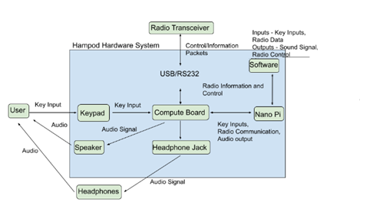
Figure 1: High-level Functional Architecture
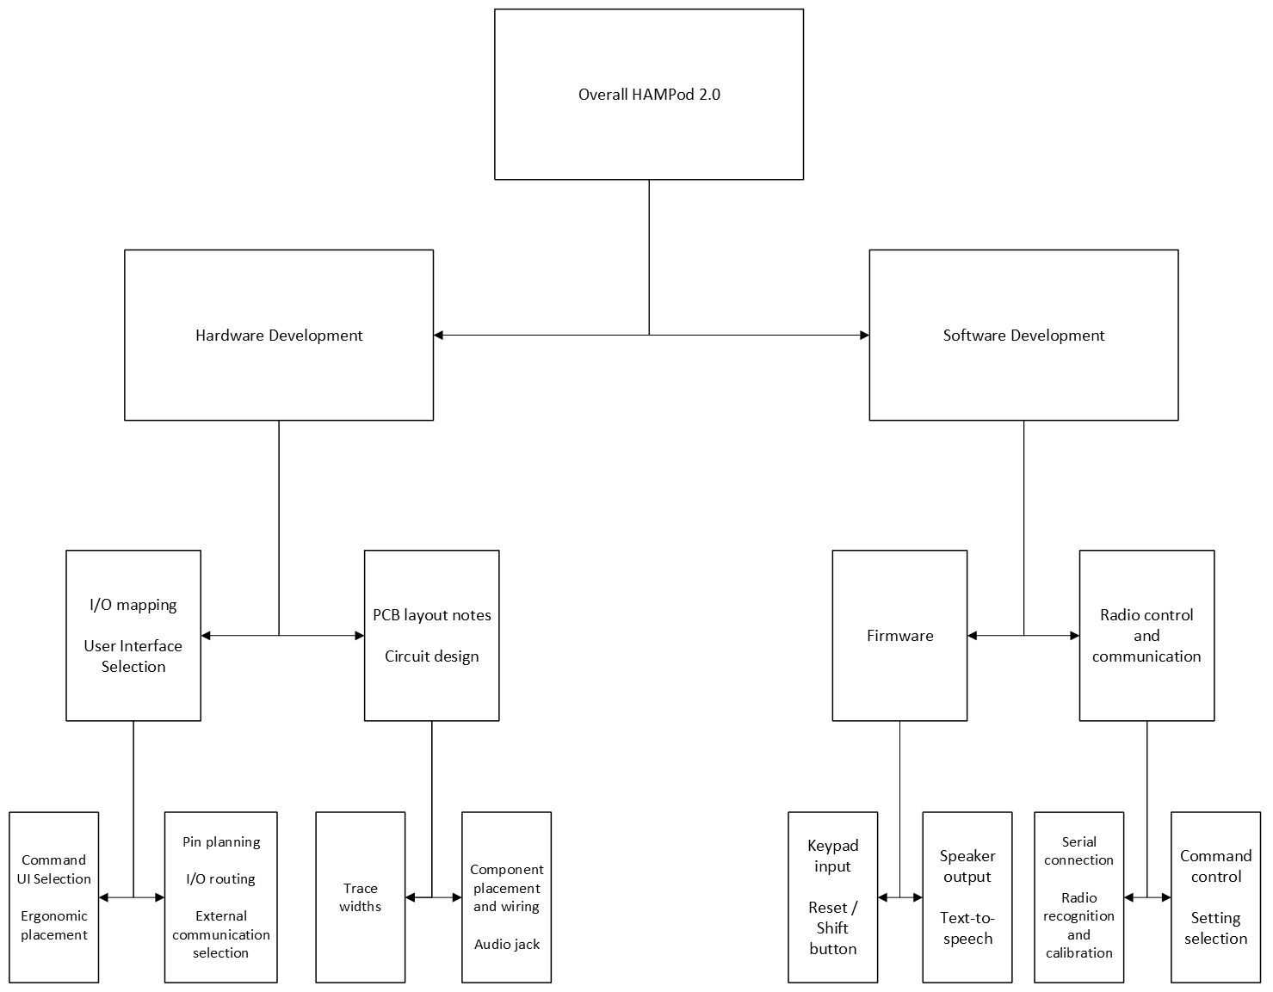
Figure 2: The High-level System Architecture

In Fig. 2, the Hampod2 system is decomposed into its respective hardware and software components. The hardware is composed of the User Interface, through which actors send inputs through the keypad, which will help to control and communicate with the radio system and receive outputs in the form of speech. The software component interprets the inputs from the user, translates them into the corresponding HAM library command, and controls the amateur radio through Serial connection. The software also takes information about radio settings and status. It can relay this information along with other key system information through the hardware speaker system using a text-to-speech synthesizer. This high-level architecture is how blind and visually impaired operators utilize and benefit from the Hampod2.

Speaker Output & Text-to-Speech
The LM4876 amplifier outputs the audio from the system. The system’s text-to-speech software is responsible for the feedback provided to the user. Specific audio feedback messages, such as voice prompts and error messages, are triggered when the user interacts with the system. The software handles the parsing of text data to ensure it is formatted for speech output. The system uses the Festival text-to-speech synthesizer to generate the wave files that are outputted through the audio system. There were previously problems with latency with audio, which caused the system to speak and “progress” very slowly. One design decision we made was to have the text-to-speech synthesizer create all the wave files before the user operates and store these files in the image on the SD card. This way there is no time wasted on creating each wave file, and latency is significantly reduced. Furthermore, users can control the volume and speed of the audio to help suit their preferences.

Radio Control and Communication
The radio control and communication is responsible for interfacing with the connected radio transceiver, managing communication protocols, and executing commands. The system interprets user input and translates the input into radio commands, sending the signals to the connected transceiver. The Hampod is able to perform frequency tuning, manage communication protocols, switch between bands, and change modulation modes. The Hamlib library enables control of radio transceivers and supports communications protocols, including RS-232 and USB protocol. The radio control and communication uses the Hamlib library’s API to send commands and receive responses. To properly configure the Hampod for the appropriate radio, the user has two options on startup.

2.1.2.1 Startup
If the user is using the Hampod for the first time or with a new radio, they will have to go through the non-save startup. On the other hand, repeat users can create configuration files for their radio which will be discussed later in this section. Both startup processes go through the same set of initial steps as shown in Fig. 3.
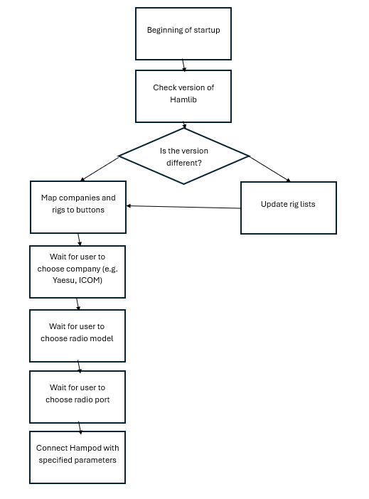
Figure 3: The startup process for the Hampod
This process uses the Hamlib library’s API which allows the user to find their radio model and make by going through a list of models and makes provided by Hamlib. This allows the user to set up the Hampod for their specific radio. For the save startup process, if the user has already created a configuration file for their specific radio model, the user can additionally load up the Hampod with that configuration file. This allows them to save default configurations for a variety of different parameters on their radio. As developers continue to expand, further parameters will be able to be configured in a file.

2.1.2.2 Mode Switching
Once past startup, the Hampod system can enter 3 modes, as detailed in Fig. 4, Frequency, Normal, and Config. Frequency mode lets the user change the frequency. This Config mode lets the user save and change multiple different settings for multiple configurations. Normal mode offers sixty different get and set commands, such as getting and setting the squelch tone, noise reduction, microphone gain, and SWR. The user can choose between these modes simply by hitting keys 1-3, corresponding to each mode. When inside a mode, the user can return to mode switching by holding the “B” button.

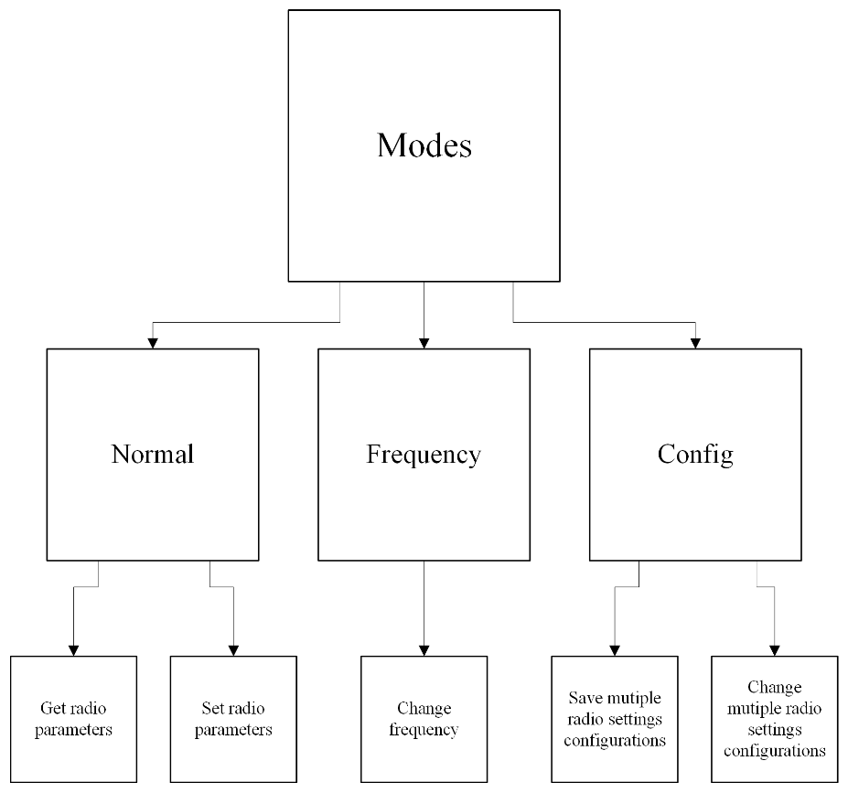
Figure 4: Mode Description

2.1.2.3 Frequency Mode
We dedicated an entire mode to frequency because shifting the frequency of the transceiver you are working with is a vital and common function that of course spans over a wide range of numbers. Therefore, having a mode dedicated to frequency changing is intuitive and helpful for the user. When in frequency mode, there is only one functionality: using the keypad numbers to enter the new frequency for the radio. The process is shown in Fig. 5 below.
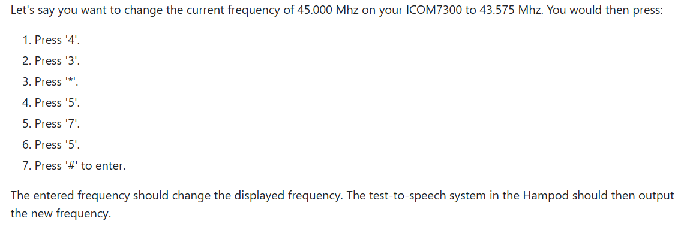
Figure 5: Example of User Manual section detailing frequency changing

2.1.2.4 Config Mode
As mentioned before, Config mode allows you to save multiple configuration files for your radio which you can load up on startup. Within the mode, the user can navigate to one of nine configuration files. Within each file, there are a number of possible parameters that can be edited. For example, the user can have a default frequency, SWR, squelch tone, etc. As developers expand the code base, these parameters will also expand. For each parameter, the user can change the value and save those changes to the file. The button mapping can be seen in Table 1.

Table 3: Button Mapping for Configuration Mode
 | Button Function
0 | Back
2 | Increment current value
4 | Prior setting
5 | Further setting options
6 | Next setting
7 | Cancel changes
8 | Decrement setting
9 | Confirm changes

Each parameter also has a certain set of characteristics that define it, such as the name of the parameter, the type of parameter, etc. This information is important to what the parameter does (numeric parameter vs. on/off for example). Below, in Table 2, is a table with the current parameter characteristics.

Table 4: Configuration Parameter characteristic table
Parameter Type | Description | Possible Values | Does order matter/ required for what type
Name | Sets the name for the config | Any name | Must be first
Type | Sets the input type for the config | OnOff  Number  OnOffNumeric  Selection  Other | Must be second
Default | Default value for the config | Integer | For all types
MinValue | Minimum value the config can be set to | Integer | Number, OnOffNumeric
MaxValue | Maximum value the config can be set to | Integer | Number, OnOffNumeric
StepSize | Increment/Decrement size for config | Integer | Number, OnOffNumeric
SelectionSize | The number of items in a list to choose from | Integer | Selection
SelectionSet | The list of items to choose from | Comma Separated Strings | Selection

2.1.2.5 Normal Mode
Normal mode is the default starting mode for the Hampod. It contains most of the useful features for the rig you are working with. As mentioned before, this mode has a vast number of get/set functions for different information about the user’s rig. Currently, since there are many functions, a shift and hold methodology is used with the keypad. The “A” button is treated as the shift button and hold simply means holding a keypress. Some functions will require a certain amount of shift presses (“A” presses) and then a hold of a different key. For example, to set tone control, one must press “A” twice and then hold 0. The full button mapping can be seen in Table 3 below.
Table 5: Normal Mode Commands based on Button Press.
P - Press Button; S- Press Shift ('A') Button; H - Hold Button; DS - Double Press Shift Button
 | P | H | S P | S H | DS P | DS H
0 | Get Noise Reduction | Set Noise Reduction | Get Compression | Set Compression | Get Tone Control | Set Tone Control
1 | Get VFO A Frequency | Get Current VFO | Get VFO B Frequency | Set VFO B Frequency | Get VFO C Frequency | Set VFO C Frequency
2 | Get Current Mode | Set Mode | Get Current Mode | Set Current Mode | Get VFO Lock | Set VFO Lock
3 | Get PTT Status | Set PTT Status | Get Passband Tuning Input | Set Passband Tuning Input | Get Passband Tuning Output | Set Passband Tuning Output
4 | Get RIT Status | Set RIT Status | Get RIT Offset | Set RIT Offset | Get Noise Blanker | Set Noise Blanker
5 | Get XIT Status | Set XIT Status | Get XIT Offset | Set XIT Offset | Get Squelch Control | Set Squelch Control
6 | Get IF Shift | Set IF Shift | Get Automatic Gain Control | Set Automatic Gain Control | Get Squelch | Set Squelch
7 | Get VOX Status | Set VOX Status | Get Audio Frequency | Set Audio Frequency | Get RF | Set RF
8 | Get VOX Gain | Set VOX Gain | Get Microphone Gain | Set Microphone Gain | Get RF Power | Set RF Power
9 | Get VOX Delay | Set VOX Delay | Get Audio Balance | Set Audio Balance | Get SWR | Set SWR

There are hundreds of additional functions in the Hamlib library, and as developers expand, they will want to add some of these functions. That is why we made the design decision to add one additional row to our keypad. This will allow several additional functions to be added to the Hampod and keep this mode’s operation intuitive.

Internal Circuitry and PCB Design
Our system utilizes a combination of 3 separate boards, including a keypad to take user input, a third-party computer in the NanoPi neo, and a compute board that connects them and provides physical connections to connect to radios. An image of the keypad is displayed below in Fig. 6, and the circuit schematic for the keypad is shown in Fig. 7.

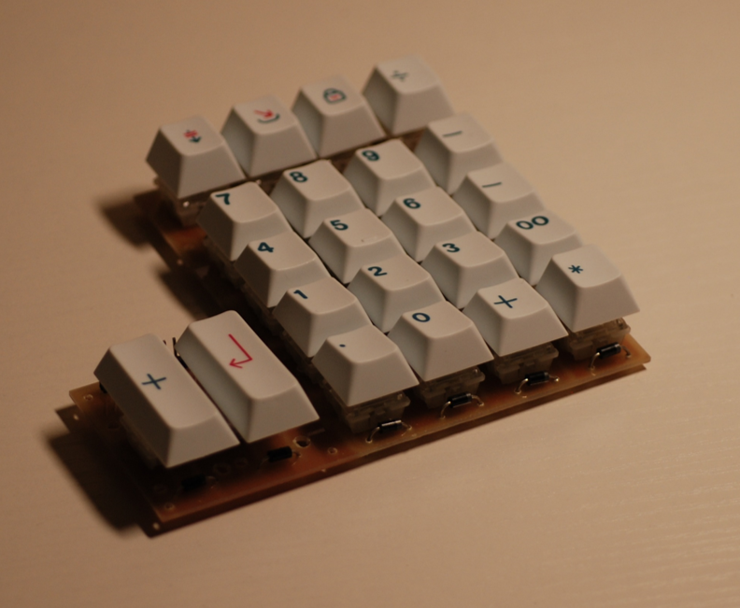
Figure 6: Image of Keypad
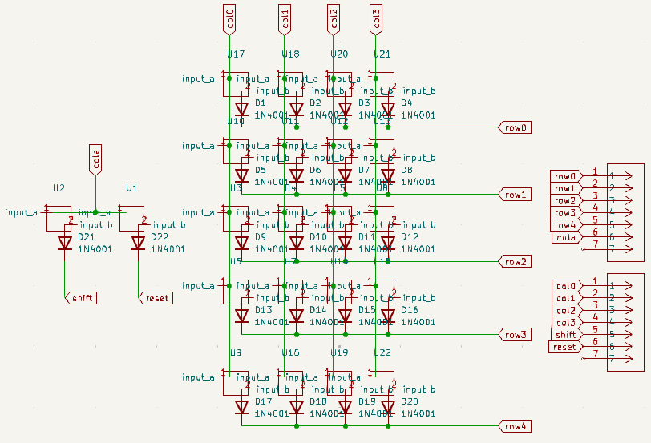
Figure 7: Circuit Schematic for the Hampod2's keypad

The keypad is a dual matrix setup, which allows for a shift or clear key and an input to be pressed and recognized simultaneously. The PCB layout (shown in Fig. 8 below) was designed to be able to be configured to be used in either a left- or right-handed configuration.
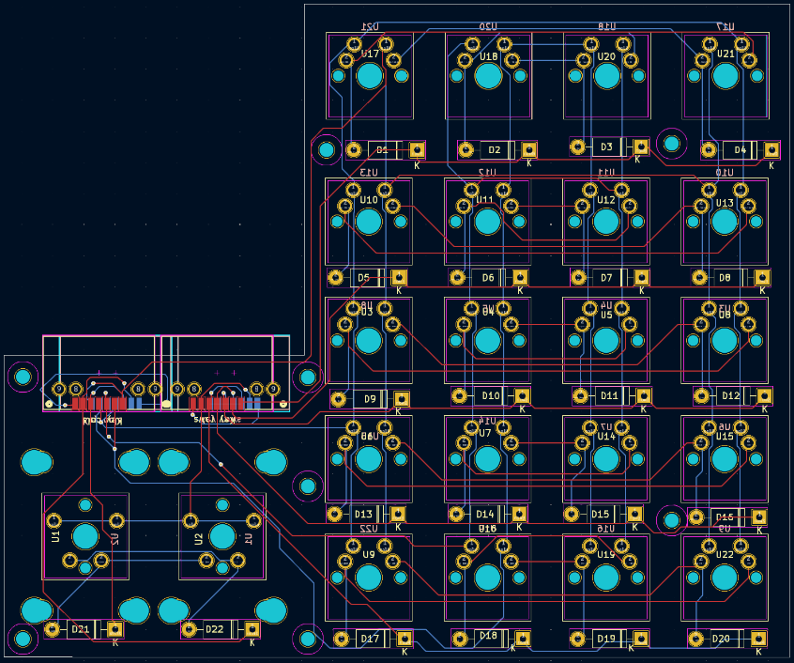
Figure 8: Hampod2's keypad PCB layout

2.1.3.1 The NanoPi NEO
Our choice for the brain of our Hampod was the NanoPi. This computer facilitates all computation, I/O signals, etc. We chose the NanoPi because of its low price combined with its ability to satisfy our power and computational needs. One of the most important features of NanoPi is the MicroSD card slot. This allows us to load an SD card with our code and configuration files, allowing for much more disk space. This SD card is where we store all our software, as well as the necessary bootup and running code needed for the NanoPi, in one image file. There is also wave files for our audio output, hardware files for our physical design, and some other miscellaneous data stored in the image. Furthermore, the additional space in the SD card is important for future developers to add to the code base, make additional wave files, and expand the design in other ways. In Fig. 9 below, shows the pinout and board layout of the NanoPi NEO v1.4.

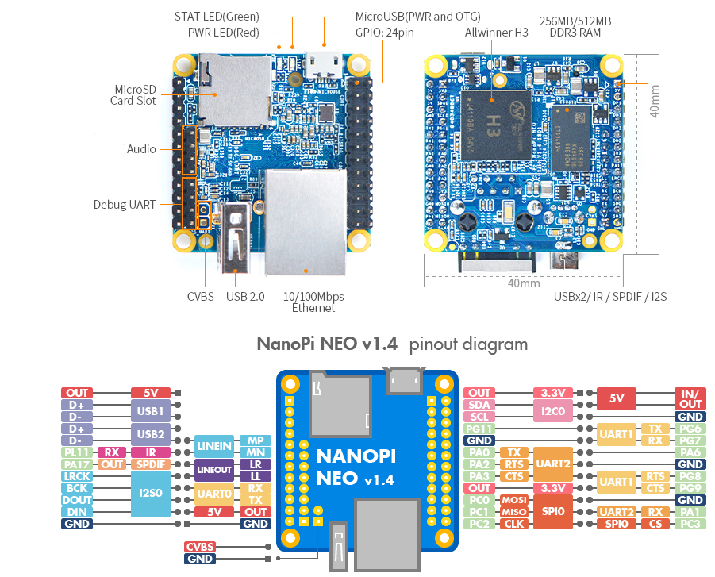
Figure 9: NanoPi NEO pinout diagram

2.1.3.2 The Compute Board
The compute board is the host board for the NanoPi. It has power delivery, audio amplification, a connection to the speaker, a MAX chip to allow for easy RS232 communication, a UART connection to the NanoPi for debugging, two USB ports, an RS232 port, a headphone jack that automatically switches off the built in speaker, a fuse to prevent an overcurrent scenario that could fry the board, LED indicators that the power systems of the board are working, connectors to the keypad, and mounting holes to secure it to a case. Fig. 10 below shows the schematic for the compute board, Fig. 11 shows the corresponding PCB layout and wiring for our schematic, and Fig. 12 shows an image of the printed compute board with the corresponding functionality highlighted.

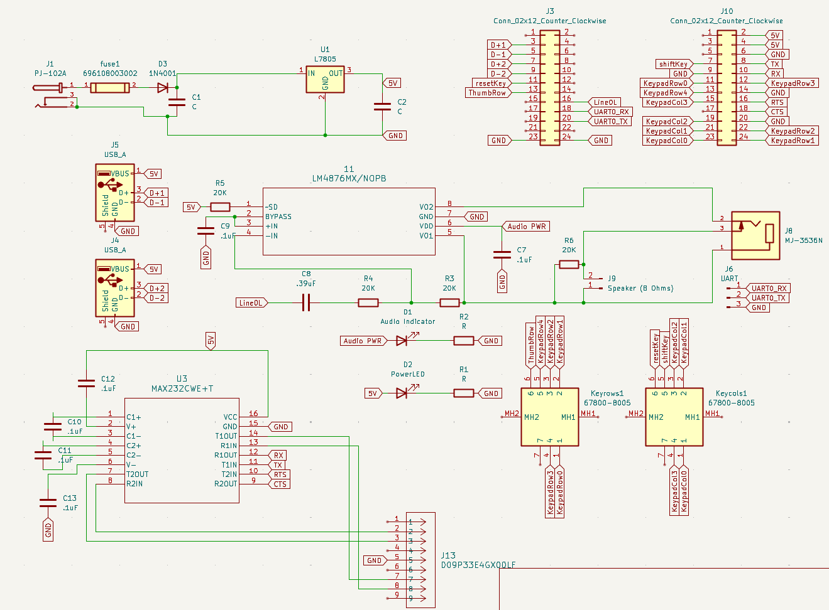
Figure 10: Hampod2 compute board circuit schematic
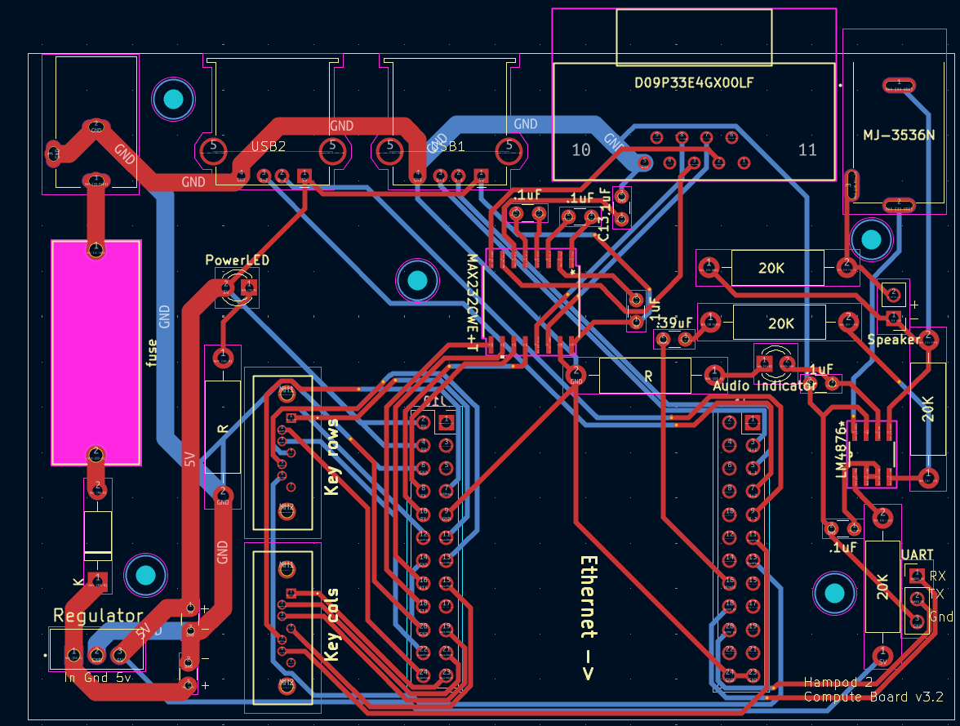
Figure 11: Hampod2 compute board PCB layout

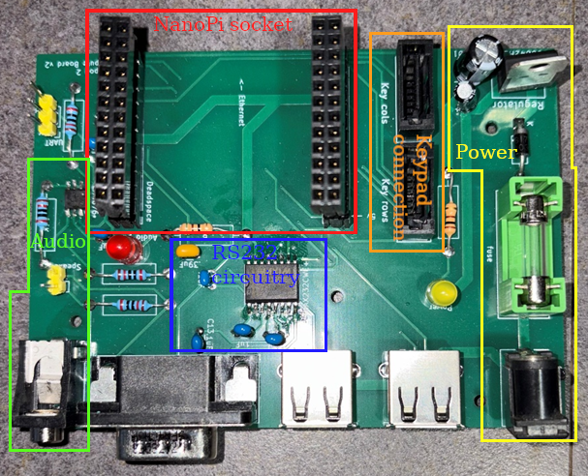
Figure 12: Hampod2 compute board prototype

Verification of Requirements
Table 6: Verification of requirements for the Hampod 2.0
Features | ID | Requirements | Verified By | Achieved
Robust | R1.0 | The Hampod will successfully setup and connect to the radio with 95% success(no crashes) | Connect our Hampod to multiple radios and run multiple set ups, recording the number of crashes | Y
Robust | R1.1 | The Hampod will successfully maintain connections to the radio and function properly according to user commands for 5 minutes | Connect our Hampod to multiple radios and run multiple set ups, run the whole list of commands and record any bugs. The timer begins when the first command is issued. | Y
Robust | R1.2 | The Hampod should automatically attempt to reconnect to the radio within 5 seconds if the connection is lost | Simulate a connection drop during testing and verify that the device reconnects within the specified time frame | N
Robust | R1.3 | The Hampod shall provide a clear error tone if it cannot establish or maintain a connection with the radio | Disconnect the device during use and verify that an error tone is played | Y
Robust | R1.4 | The Hampod shall operate continuously without crashing for at least 4 hours under normal use conditions | Conduct continuous operation tests by simulating user input for 4 hours, monitoring for crashes, freezes, or other bugs | Y
Robust | R2.0 | The device should withstand a drop from 1 meter without loss of functionality or damage to casing | Conduct drop tests from 1 meter onto different surfaces and then assess the functionality of the device afterward | Y
User-Friendly | U1.0 | The input system for the user, keypad or otherwise, allows user to input commands simply and intuitively allowing them to issue their first command within 30 seconds. This is referring to the duration from power-on to the first command. | We will measure how much time it takes for the user to start listening to their desired channel once they begin using the Hampod UI. This time will begin when the Hampod is connected and fully-powered on to when the user finishes inputting their first command. | Y
User-Friendly | U1.1 | The Hampod’s keypad layout should allow users to find and press any key within 2 seconds | Conduct a user study where participants locate and press specific keys, measuring time taken to confirm average times under 2 seconds | Y
User-Friendly | U2.1 | The latency of the text-to-speech feature of the Hampod should be less than 250 ms | We will measure the time between a text input and the speaker’s speech output. This time will begin as soon as the user touches the first key and ends when the Hampods outputs the corresponding audio to that key input. For example, if ‘A” is pressed, the Hampod ouputs “A” in speech. | Y
User-Friendly | U2.2 | The Hampod should allow the user to customize the volume and speed of audio feedback within 1 minute. | Test with users to adjust the volume and speed settings, timing the process to ensure it can be completed within 1 minute | N
User-Friendly | U2.3 | The Hampod should provide immediate auditory confirmation after each button press | Measure the time from button press to feedback, ensuring it is under 100 ms | Y
Documented | D1.0 | Using the setup manual, the setup process will take within 5 minutes starting from the initial package | Utilizing user testing, measure the amount of time to setup the Hampod starting from the initial package This will start when the user begins to open the initial package and ends when they physically connect the Hampod to the radio. | N
Documented | D1.1 | All provided manuals should be able to be read by computers, providing a voice format to the manual | We should feed our manual into an online computer reader, and see if it can clearly and accurately “speak” the manual. | Y
Documented | D1.2 | The user manual shall allow the user to troubleshoot all things that are common issues within 5 minutes for each common issue. A list of common issues will be found in the manual; that is what this requirement is referring to. | Test with users by simulating these common issues and verifying they can utilize the documentation to resolve them | Y
Configurable | C1.0 | The radio should be able to work with at least two different types of Ham radios with full function. | We will test the Hampod across different models of radios and it should work without additional setup. We will test all necessary commands across those models and ensure all work. | Y
Configurable | C1.1 | The radio should be able to be additionally configured to work with any supported Ham radio within 2.5 min | We will utilize user-testing and measure the time it takes for the users to configure their Hampods for the radios. This time will start when the radio is on and the Hampod is connected to the moment the Hampod issues its first command. | N
Configurable | C1.2 | The Hampod shall allow users to save settings for at least 3 different radio profiles | Configure and save settings for three distinct radios, and switch between radios verifying these are the correct settings | Y
Configurable | C1.3 | The Hampod should have a reset function that restores default settings within 5 seconds of input | Test that inputting the reset function reverts to default settings, completing the reset process within 5 seconds | Y
Affordable | A1.0 | The BOM for the Hampod should be below $100. | We will keep a list of all the materials/parts/etc. used in the production process and create a BOM from this. | Y
Affordable | A1.1 | The Hampod’s repair parts shall cost less than $30 per component to ensure affordability for users | Track the cost of each replaceable component to confirm compliance with the $30 limit | Y
Manufacturable | M1.0 | The package for the product should be within 4x6x6 inches | We will measure the dimensions of our final package for the finished product | Y

Feature: Robust
The Robust feature describes the ability of the Hampod to consistently connect to the radio and communicate and configure settings without bugs or crashes. It also describes the physical strength of our casing and the ability of the Hampod to detect connectivity issues and try to resolve them. Our Hampod solution was able to consistently connect to the radio, issue commands, and function properly for a long duration of operation without bugs or crashes. This can be seen by the design meeting requirements R1.0, R1.1, and R1.4. Furthermore, the Hampod could alert the user of any errors occurring during operation through a clear error tone as shown by meeting requirement R1.3. However, the design was not able to meet the reconnection requirement of R1.2. The reason our design did not meet this requirement is because of our time limitation on the project. We believe this requirement is less pivotal to the functionality of the Hampod, as we have already tested for normal crashes through the other requirements. Therefore, this requirement does not significantly hamper the design for the stakeholders. The Hampod also did not meet the physical requirements for the casing as shown by Requirement R2.0. The reason it did not meet this requirement is because we were unable to test this requirement. Due to lack of financial resources and time resources in the case of this requirement failing and our Hampod breaking (since it is a physical stress test), we could not test it. However, we believe this requirement, even if failing, would not significantly hamper the design for the stakeholders. It would just indicate greater care is needed when carrying the Hampod.

Feature: User-Friendly
The User-Friendly feature describes the ability of the Hampod to be utilized by visually impaired users with ease. This includes detailed, comprehensive, and clear audio information while operating the Hampod, but also surrounding documentation to provide help while operating. Our Hampod design included a keypad that provided a very nice feel and great tactile feedback making it easy to utilize as shown by Requirement U1.1. The software flow of the Hampod was also intuitive to follow, making it easy to connect to the radio and begin issuing commands as shown by Requirement U1.0. The audio system works hand in hand with the rest of the system and gives the user status on where they are in the system and confirmation of what commands they have issues, radio changes, and other info as shown by Requirement U2.3. There were other audio problems with the system, however. It was unable to meet latency requirements as shown by Requirement U2.1. The reason it did not meet this requirement is because the system would generate a new wave file in real time when the user “asked” for it. We believe that changing the system to generate the wave files and store them on the SD card before the user begins operating the Hampod would enable the Hampod to meet this requirement. The other issue was that the user could not adjust the speed of the voice as shown by Requirement U2.2. The reason the Hampod did not meet this requirement is because it could only control the volume of the audio, not the speed, but we believe that improving the text-to-speech synthesize and adding speech controls as a configuration in Config mode would easily enable the system to meet this requirement.

Feature: Configurable
The configurable feature describes the Hampod’s ability to adapt to its settings and behavior to different radio models while offering users the ability of saving, switching, and restoring configurations. The Hampod system was able to save multiple configurations for different parameters for a single radio and load those configuration parameters onto the radio with a “reset” button as shown in Requirements C1.2 and C1.3. However, this testing was only done with the ICOM, so the Hampod was not verified as being able to configure more than one radio as shown by Requirements C1.0 and C1.1. We were not able to meet requirements C1.0 and C1.1 because there were not any other radios set up in our equipment room at the time of testing, and we were not able to get the equipment in time, but theoretically, the software should be in place, allowing the system to meet these requirements as well.

Feature: Documented
The documented feature describes the documentation that comes with the Hampod, such as the User Manual, User Guide, and Developer’s Guide, that allows the user to set up and use the Hampod. This includes detailed, comprehensive, and clear instructions on how to operate the system. All the manuals that come with the Hampod will be able to be read by computers, providing a voice format to the manual as shown by Requirement D1.1. As shown in Requirement D1.2, the User Manual and User Guide allows the user to troubleshoot all things that are common issues within 5 minutes for each common issue, and a list of common issues can be found in the User Manual. The system was unable to meet the intended setup time as shown in Requirement D1.0. We were unable to test this requirement due to lack of time. We believe this requirement, even if failing, would not significantly hamper the design for the stakeholder.

Feature: Affordable
The affordable feature ensured that our device remains cost-effective for a wide range of users, without compromising on performance or robustness. This feature specifically addresses the requirement to keep the Bill of Materials (BOM) below $100 (Requirement A1.0) and to ensure each replaceable repair part costs less than $30 (Requirement A1.1). By selecting materials and components and confirming that each part remains under the stated cost thresholds we have verified that all affordability requirements are met. We maintained a list of every material and part, comparing our expenses against our budget. By using this approach, we were able to avoid unnecessary spending and verify that we met both of our affordability requirements to keep maintenance and repairs accessible for users. Meeting all of our affordability requirements supports our goal of providing an economically accessible solution while improving the devices core functionality and quality.

Feature: Manufacturable
The manufacturable feature describes the ease of which new Hampod2 units can be assembled. This includes the ease of acquiring the requisite parts, assembly of the electrical system, and installation of the software. The verifiable requirement for this feature was to have the final product be within 4x6x6 inches. This would allow the many devices to be handled more easily and would allow the final product to take up less overall space. Intentionally keeping board sizes down has the additional benefit of improving the affordability of the device. Our final design passes this requirement. If the Hampod 2 were to enter into mass production, other additional savings on both cost and ease of assembly could be made, but such optimizations were not in the scope of our work on this project.

Project Plan and Timeline

Original Timeline Description
Milestone 1: Begin investigation of project status
- Identify the previous group’s progress
- Detail the current features and bugs
- Determine improvements necessary to the project’s functionality
- Meet with the clients and understand the expectations, features, and final deliverables for this project.
Milestone 2: Research and experiment with HAM radios, Hampod, and Hamlib
- Do research on the Hampod, its history, and its general functionality
- Furthermore, research how Hamlib communicates with radios
- Get technician and general radio licenses
- Develop 2 research memos
- Investigate current Hampod setup and program
Milestone 3: Hardware system redesign and upgrade
- Redesign the hardware platform to allow for an upgraded keypad implementation or alternative implementation such as a touchpad, as well as a more efficient board layout
- Improve compute board design to fix bugs
- Build new UI and order new compute board
Milestone 4: Software system redesign and upgrade
- Rework the software to allow for smoother and quicker operation of the device
- Solve audio latency isssues
- Remove bugs and crashes from software
- Implement full functionality of Hampod
- Allow for developers to expand software
Milestone 5: Combine hardware and software system
- Integrate the hardware design with the software design
- Find any initial bugs and resolve
- Create an initial prototype ready for testing
Milestone 6: Internal testing
- Determine full suite of testing requirements
- Test the prototype across full suite of requirements relating to functionality and performance
- Make small appropriate fixes during test process
Milestone 7: Finalize prototype
- Based on test results, modify and fix last small bugs with finalized prototype
- Create a more advanced prototype that resembles product with finished packaging, user manual, and other necessary components
Milestone 8: Conduct user-testing
- Develop user-testing process, surveys, and data collection process
- Conduct user-testing with blind and visually impaired HAM operators and gather their feedback on the finalized prototype and surrounding documentation
- Compile results of user-testing into graphics and excel sheet
Milestone 9: Implement user feedback
- Based on user-testing results, implement plan of action and improve features/design aspects to meet user needs as fully as possible.
Milestone 10: Finalize finished product and documentation
- The product is finalized with all functionalities finished, packaging and casing finalized
- All documentation surrounding setup, usage, software, and more is finalized.
- Product is in its final state that we can present to the client and Rose community at large at the Rose show.
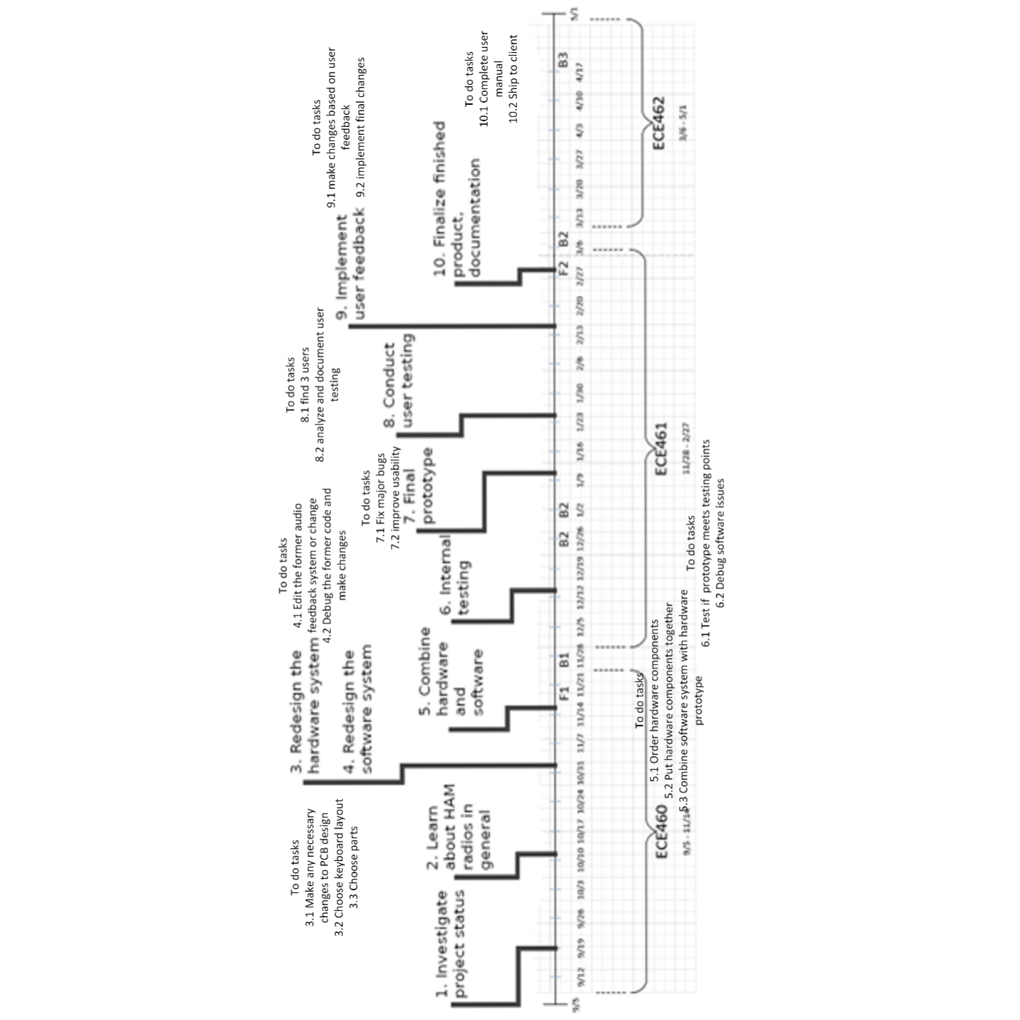
Figure 13: Original timeline

Final Timeline and Reflection
- Milestones 1 & 2:
Achieved as planned with no significant issues.
- Milestone 3 – Hardware System Redesign:
  - Deviation: This milestone experienced delays.
  - Causes:
    - Lengthy international shipping times for essential parts to build hardware system
    - Increased course requirements for planning and system documentation that we did not expect
  - Impact: The delay in hardware redesign subsequently pushed back the remaining milestones delaying our entire project completion, and led to us having to deal with
hardware bugs later than expected leading to improvements later than expected and so forth.
- Milestone 4 – Software System Redesign:
  - Deviation: Progress was limited until the new hardware system was completed, and unexpected issues in the software led to delays in this completion.
  - Causes:
    - Dependence on the hardware redesign for full-scale software testing.
    - Interim testing was conducted with the old hardware, which did not fully reflect the new system’s performance.
    - Most importantly, there were bugs/errors with the old system that were not reported by the old team and less progress was made than we believed
  - Impact: The delayed hardware and substantial improvements needed led to a corresponding delay in the software redesign timeline, affecting all subsequent milestones.

Lessons Learned and Future Recommendations
- Recognizing External Dependencies:
  - Situation: Delays caused by international shipping and strict documentation requirements.
  - Future Recognition: Monitor and research vendor lead times and course documentation requirements early in the planning phase.
  - Plan Adjustments:
    - Identify and source components from suppliers with reliable shipping records.
    - Incorporate buffer periods in the timeline for potential external delays.
- Optimizing Downtime:
  - Situation: Idle time occurred while waiting for the hardware system to be ready.
  - Future Recognition: Look for early indicators such as delayed shipments or extended documentation cycles.
  - Plan Adjustments:
    - Utilize academic breaks or downtime to place orders.
    - Reallocate resources to preparatory tasks that can be completed while awaiting hardware delivery.

- Managing Interdependencies:
  - Situation: The software redesign was hindered due to its reliance on the hardware completion.
  - Future Recognition: Realize early on that delays in one component can have a cascading effect.
  - Plan Adjustments:
    - Develop contingency plans where parallel work or preliminary testing can occur without the final hardware.
    - Enhance cross-team communication to swiftly adapt to shifts in the timeline.
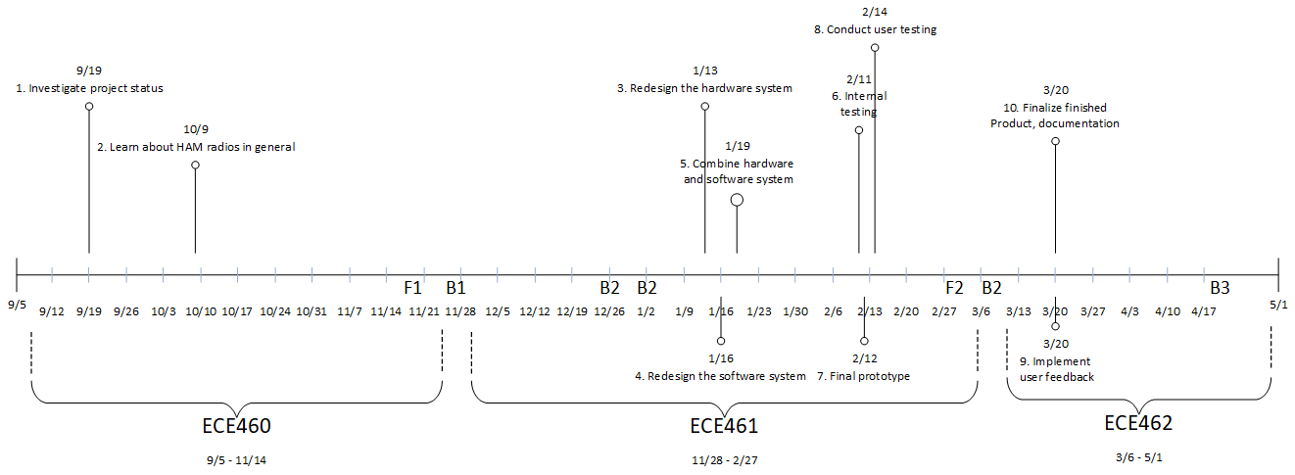
Figure 14: Final timeline

Budget

Labor Costs

Figure 15: Labor cost by type breakdown

Figure 16: Detailed breakdown of labor costs by category

Table 7: Labor Budget Breakdown
Type | Cost
Student Hours | $17830
Faculty Hours | $150
Engineer Hours | $1260
Total | $19240

Costs of Materials

Figure 17: Non-labor material costs incurred by the project

Table 8: Budget Overview
Type | cost
Labor | $19240
PCB | $57.06
Parts | $175.13
Total | $19,472.19

Table 9: Detailed Budget Breakdown
Item | Type | Cost
Student Hours Fall | Labor | $7260
Student Hours Winter | Labor | $7660
Student Hours Spring | Labor | $2910
Faculty Hours | Labor | $150
Engineer Hours | Labor | $1260
Keypad PCB | PCB | $20.1
V1 Board | PCB | $9.53
V2 Board | PCB | $17.9
V3 Board | PCB | $9.53
First Round of Parts | Parts | $112.63
Second Round of Parts | Parts | $62.5
Total | Labor & Parts | $19472.19

Table 10: Single unit BOM
Part Number | Qty | Unit Price | Qty Cost | What is it?
LM4876 | 1 | $0.41 | $0.41 | Audio amp
MAX232CWE+T | 1 | $7.20 | $7.20 | RS-232 interface
L7805CP | 1 | $1.22 | $1.22 | Voltage regulator
77313-124-24LF | 2 | $1.53 | $3.06 | Pins for pi
TLHG5420-ASZ | 2 | $0.53 | $1.06 | LED
SJ3-35063B | 1 | $1.15 | $1.15 | Headphone Jack
Z4KE140A-E3/54 | 23 | $0.10 | $2.30 | Regular diodes
C322C394M5U5TA | 1 | $0.47 | $0.47 | .39uF
MF1/4DCVTR2002F | 3 | $0.26 | $0.78 | 20kOhm
CFS1/4CVTR103J | 1 | $0.25 | $0.25 | 10kOhm
LR1F1K6 | 2 | $0.10 | $0.20 | 1.6kOhm
SL151A1R2CAB | 7 | $0.45 | $3.15 | 1uF
K104M20X7RH53L2 | 1 | $0.29 | $0.29 | .1uF
10PX2200MEFC10X16 | 1 | $0.67 | $0.67 | 2200uF
USB1130-15-A | 2 | $0.83 | $1.66 | USB
D09P33E4GX00LF | 1 | $2.23 | $2.23 | RS-232
Keychron K Pro Switch | 22 | $0.13 | $2.86 | Key switches of choice
ePBT Numpad Kit Collection | 1 | $8.50 | $8.50 | Numpad keycap kit of choice
PJ-102A | 1 | $0.74 | $0.74 | DC jack
696108003002 | 1 | $0.68 | $0.68 | Fuse Holder
5MF 1-R | 1 | $0.37 | $0.37 | Fuses
GF0776M | 1 | $5.42 | $5.42 | speaker
WM19103-ND | 2 | $1.09 | $2.18 | SATA Port (compute board)
SAT3M2132072TR | 2 | $1.81 | $3.62 | SATA Port (keypad)
123-AK-SATA-015-ND | 2 | $0.72 | $1.44 | SATA Cable
HAMPOD PCB | 1 | $1.46 | $1.46 | Compute Board
Keypad PCB | 1 | $1.85 | $1.85 | Keypad PCB
NanoPi NEO-LTS | 1 | $15 | $15.00 | NanoPi
SanDisk Extreme microSDXC™ UHS-I CARD- 32GB | 1 | $9.49 | $9.49 | SD card (reputable brand)
 |  | Total | $79.71 | (some costs are amortized, no costs include shipping)
The most significant portion of the project’s budget was labor while the costs of parts and revisions were relatively small – a goal we aimed to meet through our “Affordable” feature. Breaking down the labor costs further reveals that student labor made up the vast majority of labor expenditures. Unfortunately, due to the nature of the project, it is not possible to reduce the cost of student labor without sacrificing overall quality.

However, there were several non-monetary costs that could be reduced for future projects. These include more thorough proofing on board revisions before sending them to be fabricated, spending less time planning how to begin planning the project, and not using inferior in-house PCB manufacturing capabilities. Another, more efficient version of this project might also reduce the number of meetings from weekly to biweekly. Along with this, more efficient planning, could reduce the length of meetings as well.

There were only a couple of theoretically unnecessary additional costs, including a third round of PCB manufacturing, spare nanoPi NEOs, and replacement SD cards. Ideally, with a more through design review, the errors in the second version of the PCB would have been caught and fixed before it was sent off to be manufactured. Overall, even considering these unexpected costs, our final budget fared well compared to our initial budget, with our total non-labor related costs of $232.19 being below our initial budget goal of $300.

Recommendations

Quality Assessment
Reflecting on the development of the Hampod, we are proud of the overall quality of our solution. Our team succeeded in addressing many core stakeholder features with high effectiveness, while also identifying several areas for future improvement.
One of the most successful aspects of our solution was robustness. The Hampod performed consistently and reliably during testing, demonstrating stable operation over extended periods without crashes. This level of reliability ensures that blind and visually impaired users can depend on the device during real-world use—a crucial requirement for assistive technology.
In terms of user-friendliness, our improvements were well-received. The integration of a new mechanical keyboard and reduced auditory system latency significantly enhanced the usability of the system. Feedback from user testing affirmed that these changes had a meaningful impact on accessibility. However, further enhancements could be made. Specifically, reducing latency even more, improving the clarity and naturalness of the voice output, and offering customizable audio speed would deepen the user experience and accessibility.
Our system also met the configurable feature with reasonable quality. We successfully demonstrated compatibility with two radios and provided a user-friendly method for saving and loading configurations. These capabilities are essential for HAM radio operators who rely on different setups. Yet, our progress here was limited by the number of radios available for testing. Expanding compatibility and offering more adjustable parameters would further strengthen this feature.
We achieved strong results in documentation, which will support future developers and users alike. The inclusion of a well-organized Developer’s Guide, a User Manual, and a User Guide ensures that others can easily understand, maintain, and improve the Hampod. This thorough documentation was a key strength of our project.
Our approach to affordability was also successful. According to our bill of materials (BOM), we remained well under our $200 target cost. This suggests that the Hampod can be an economically viable solution for a wide audience of amateur radio enthusiasts.
On the other hand, manufacturability was an area where we see room for growth. While we created a functional prototype case and a finished design, there is significant opportunity to refine the dimensions and design details for mass production. Since manufacturability was not a primary focus during this phase, it remains an important consideration for the next stage of development.
From a teamwork perspective, our collaboration was strong in planning and execution. We divided tasks effectively, communicated consistently, and maintained steady progress toward our goals. However, we could have benefited from allocating more time earlier in the project timeline for user testing and iterative hardware refinement. These activities would have provided additional insights and potentially led to an even higher-quality final product.

Future Directions
While the current Hampod prototype successfully delivers on many of its intended features, there is still significant room for continued refinement and innovation. Future development efforts should focus on expanding functionality, improving usability, increasing compatibility, and preparing the Hampod for real-world deployment. Below are several specific directions that should be prioritized in the next phases of development:
1. Enhancing Configurability
Although the Hampod is currently tested with two radio models and supports saving/loading of settings, configurability can be pushed much further. One immediate improvement is to test a wider range of radios.
Additionally, more user-level parameters should be made configurable through the keypad interface. Examples include speech rate and volume presets specifically. In the user guide, adding how to specifically alter these user-level parameters would allow for a more personalized and accessible experience from the start. Another aspect to improve configurability would be to allow more personalization with the mapping of keys to functions.
2. Improving Audio System and User-Friendliness
User-friendliness, especially in an assistive technology like the Hampod, is critical. There are several enhancements that can significantly improve the auditory interface:
- Reduce Latency Further: While improvements have already been made, further optimizing the audio processing pipeline—possibly by switching to a more lightweight text-to-speech engine or using in-built commands rather than system calls—could cut latency even more.
- Voice Customization: The ability to choose from different voices, control pitch, and adjust the speech rate on-the-fly would allow users to tailor the auditory experience to their individual preferences and needs. This is especially useful for users with hearing impairments in addition to visual impairments.
- Use of Additional Keys: The new mechanical keyboard has unused keys that can be purposed for shortcut functions, context-sensitive help, or toggling features. Mapping frequently-used operations to fewer keypresses would simplify the user experience.
- Improved Navigation Feedback: Implementing audio cues that confirm menu depth, provide ideas of the user’s “path” through the system, and other helpful information would improve the user experience.
3. Improving Robustness Through Better Error Handling
The Hampod is already quite robust during supported operations, but its reliability can be further enhanced by improving how it handles unexpected conditions or user errors:
- Contextual Error Messages: Implementing more descriptive and contextual error messages with actionable guidance would reduce user confusion.
- Guide Integration: When an error occurs, the Hampod could reference a specific section in the user guide using audio (e.g., “See Section 5.3 in the user guide”), allowing users to troubleshoot independently.
- Logging and Diagnostics Mode: A simple diagnostics mode could be included, triggered by a special key combination, to audibly report system status. This feature could help both users and support staff diagnose problems quickly.
4. Refining Manufacturability and Physical Design
While manufacturability was not the top priority during the initial prototyping phase, it will become increasingly important for commercialization. Future design iterations should consider the following:
- Revised Enclosure Design: Create a 3D model of a professional-grade enclosure that is compact, durable, and ergonomically designed for blind and visually impaired users.
- Tool-Free Assembly: Redesign internal component layout to support easier assembly and maintenance improving manufacturability and reducing cost..
5. Preparing for Real-World Use and Scalability
To move from a functional prototype to a viable product, the Hampod will need to go through further testing and iteration:
- Wider User Testing: Conduct testing with a more diverse group of users from the blind and visually impaired HAM radio community to gather broader feedback.
- Accessibility Certification: Begin exploring what is required to obtain certifications or endorsements from accessibility-focused organizations, such as the American Foundation for the Blind or ARRL.

In summary, the future of the Hampod is promising, with many opportunities to improve and evolve the system based on current results. Each of these recommendations comes directly from current user feedback, observed system limitations, and stakeholder needs. Addressing them will lead to a more versatile, user-centered, and production-ready assistive technology for the HAM radio community.

Going Further Material

Standards

USB 2.0
The Hampod2 utilizes USB 2.0 to connect to radios. This standard supports data transfer rates of up to 480 Mbps and specifies requirements for signal integrity, cable lengths, power delivery up to 500 mA at 5V, and connector types, such as Type-A and Micro-B. Compliance with this standard ensures compatibility with a wide range of USB devices.

IEEE 802.3 (Ethernet)
The Hampod2 utilizes Ethernet, which conforms to the IEEE 802.3 standard. This standard defines protocols for data framing, media access control (MAC), and physical layer signaling. It also sets electrical and timing parameters to ensure reliable transmission.

Impacts of the Project on Broader Issues

Public Health, Welfare, and Safety
The main issue regarding public health that the Hampod addresses is that it can improve the ergonomics of using a radio transceiver. While designing the Hampod, one of the major considerations was the ease of use and comfort of the keypad. Our design features standard size keys in a configuration that, when compared to the original Hampod, should greatly improve the ergonomics of the device. Improved ergonomics leads to a lower risk of repetitive strain injury as well as general fatigue with using the device.
Another potential impact that the Hampod may have on the safety of the public is that it enables HAM radio operation, which in turn can be used to assist with emergency broadcasting and coordination efforts. Because the Hampod assists a demographic that is historically underserved by HAM equipment, it is possible that users who are only able to use radios because of the Hampod could exist. Many HAM operators then join emergency response networks to give back to their communities.

Global Issues
Global trade is a major contributor to the costs incurred by this project. The Hampod can be made with off-the-shelf parts and a PCB that is able to be manufactured anywhere where 2-layer boards can be. We selected off-shore suppliers for this project because the end costs were cheaper, and the lead times were shorter. Because of the suppliers we selected for our parts, the Hampod project slightly contributed to the status quo of electronics manufacturing centered in China.

Societal Issues
The Hampod at its core is an accessibility device that levels the playing field for people who are visually impaired in the realm of HAM radio. Hampod enables HAM radio operators who have lost most or all of their vision to operate their radios with relative ease. This device also opens the hobby up to visually impaired individuals who would not have developed an interest in amateur radio otherwise.

We have also made the Hampod’s code and hardware publicly available so that others can iterate on our work. This allows another group or individual to utilize the framework we have built and create another iteration on our design or simply improve the software. This allows the Hampod to be improved and modified without the need for the original team to approve every modification.

Economic Issues
The Hampod is one of a class of devices and software programs that interface with HAM radio transceivers. As the quantity and quality of these devices increases, the pressure for the manufacturers of HAM radio equipment to create more standardized communication and control protocols for their devices also increases. Ideally the Hampod, and other devices like it, lead to the creation of a standard communication protocol for HAM radios, thereby eliminating the need for such devices to use HAMLIB for their communications.

Because the Hampod can communicate with any radio that HAMLIB supports, the range of transceivers that a blind or visually impaired operator can comfortably purchase is significantly widened. Rather than focusing on built-in accessibility features, Hampod users can focus solely on the performance and price of their transceiver units, potentially allowing for a wider selection of radios to be viable for use.

One of the main design considerations for the Hampod was the device’s affordability. With a unit cost of under $100, and a previous device that sold well at $300, a company or individual could potentially make and sell Hampod’s for both a reasonable price and profit. The product segment for this market is relatively empty, with the closest analog being using a desktop computer to communicate with a transceiver. Many HAM operators would appreciate the simplicity of the Hampod compared to a setup with a desktop computer being used to control the radio.

Environmental Issues
While designing the Hampod, we intended to create a system that would be able to be easily upgraded and repaired. The hardware system is made entirely of off-the-shelf components, making replacement parts easy to acquire. Notably the switches and keycaps, the parts of the system that most directly interact with the user, can be replaced with relative ease. Another part of the system that can be replaced easily is the fuse which will fail in an overcurrent event, protecting the rest of the components from being damaged.

Looking into the longer term, if an individual Hampod continues to be used for long enough, the SD card might fail, and yet again this part can be easily replaced with another. The system can be repaired with only a microSD card as waste. If a Hampod needs to be decommissioned, the PCBs can be recycled, and the NanoPi can be used for other projects. These things all contribute to the Hampod having less waste, and therefore less environmental impact, than the average product.

System Failure Mode Analysis

6.3.1 Component Failure Mode: Power Surge at Power Jack
One critical hardware-related failure mode involves the power jack receiving a surge of power, which could result in blowing the internal fuse of the Hampod. This would render the device temporarily non-functional until the fuse is replaced.
- Outcome: If this failure occurs, the Hampod shuts down entirely, and the user will be unable to operate it. For a visually impaired user who may not be equipped or comfortable replacing a fuse, this could lead to frustration and a significant interruption in usability.
- Risk Priority Number (RPN):
  - Probability of Occurrence: 1 (very infrequent, but possible in environments with unstable power sources)
  - Severity of Outcome: 3 (causes complete failure of the device)
  - Likelihood of Detection: 2 (surge protection exists but may not always be sufficient)
  - RPN = 1 × 3 × 2 = 6
- Severity & Recommendation: This is a low-to-moderate severity issue. We recommend adding an additional layer of over-voltage protection, such as a transient voltage suppression (TVS) diode or a polyfuse that resets automatically, which would help prevent permanent damage and reduce user maintenance needs.

6.3.2 User Error Failure Mode: Selecting the Wrong Radio
A significant user error involves the user selecting an incorrect radio from the Hampod’s list of supported devices. If the system attempts to operate with mismatched commands for the selected radio, it may lead to software crashes or erratic behavior.
- Outcome: This error can lead to the system becoming unresponsive or issuing incorrect commands to the radio, confusing the user or making the Hampod appear broken.
- Risk Priority Number (RPN):
  - Probability of Occurrence: 2 (high—users may not always remember or recognize the correct radio, especially if visually impaired)
  - Severity of Outcome: 2 (may require restart or manual correction, but doesn’t cause hardware damage)
  - Likelihood of Detection: 2 (user may not realize the issue until attempting to use commands that fail)
  - RPN = 2 × 2 × 2 = 8
- Severity & Recommendation: This is also a moderate severity issue. To reduce the likelihood and impact, we recommend adding a radio-specific confirmation message when selecting a radio (e.g., “You selected Radio Model X. Is this correct?”), as well as implementing more robust error-handling code that catches incompatible command usage and provides helpful audible feedback, such as “Selected radio may be incompatible. Refer to the user guide, section 3.2.”

Bibliography
[1] “Amateur Call Sign Systems” FCC, Feb. 27, 2023. https://www.fcc.gov/wireless/bureau- divisions/mobility-division/amateur-radio-service/amateur-call-sign-systems (accessed Oct. 28, 2024)
This resource describes how callsigns are distributed and what different portions of a callsign indicate. This also includes how which region you are in affects your given callsign. This article is relevant to our project because to test our system we will have to make communications and should know how to identify ourselves and other operators. This information is reliable as it comes directly from the FCC, who licenses and oversees all amateur radio users. The information from this source is current and up to date. There is no bias from this source as it comes from a governmental agency that wants to inform amateur radio users about licensing and how callsigns are given.

[2] G. Brown, “How Ham Radio Works,” HowStuffWorks, Apr. 27, 2023. https://electronics.howstuffworks.com/ham-radio3.htm (accessed Oct. 09, 2024).
This source provides an overview of Ham radios in general such as what radio bands are used for what and a breakdown of common equipment used to make transmissions. The article also discusses licensing requirements and how to obtain a license. This source is relevant to our project because we need to know how these radios work and what they are used for to properly engineer an effective solution, this source provides a good starting point for common information to know for team members. The information on this source is current and up to date. There may be a slight bias in this source in the sense it is advocating for people to use Ham radios.

[3] “Ham Radio 101,” Arrl.org, 2018. https://www.arrl.org/ham-radio-101

This source provides answers to commonly asked questions about Ham radios as well as general information about communications using Ham radios. It also contains more licensing information and cost information for licensing. This source is relevant to our project because to make communications we must be licensed and need to be informed how to get licenses and the cost that you incur while being licensed. This information is reliable and up to date, the information comes from the website of the National Association for Amateur Radio (ARRL) who oversees all testing for licenses and the information covered in those tests. This information is not biased for the reasons previously mentioned that it was published by the National Association for Amateur Radio.

[4] How to Correctly Use an SWR Meter: A Full Guide. [Online]. Available: https://moonrakeronline.com/us/blog/how-to-use-swr-meter
This article describes what a standing wave ratio meter (SWR) is and different methods on how to use it within the ham radio context. This article is relevant to our project because SWR meters are common pieces of station equipment that the HAMPod was designed to provide speech output and accessibility to. This article does have some bias towards ham radio equipment because the website that the article is published on is a marketplace for ham radio equipment.

[5] K. Wilson, “What Is Ham Radio And How Does It Work?,” Radio Thoughts, Apr. 02, 2024. https://radiothoughts.com/what-is-ham-radio/ (accessed Oct. 09, 2024).
This article gives an overview of HAM radio; specifically, it briefly describes the history, the types of technology, how to get involved, and communication information/modes with amateur radio. This source is particularly important to our project because while giving us general information about amateur radio, it also specifically describes how to obtain our licensure and get involved which we will need to know to work with amateur radios in our project. The source is reliable, for it is authored by a telecommunications expert who also has years of experience with amateur radio. The source provides current information, as it was written in 2024. The source’s information is also accurate because, as mentioned before, the author is an expert in the field, the information is consistent with other sources, and this source has been fact-checked by another expert in the telecommunications field. The author writes this article because of his passion for amateur radio, and it is important to note that his bias is toward educating unfamiliar individuals. Therefore, he presents the information in a clear and untechnical way.

[6] Lynd, William (1884). The Practical Telegraphist, and Guide to the Telegraph Service
This book is a 19th century guide to being a telegraph operator. While most of the information provided is not particularly relevant to radio communication, the evolution of radio communication standards was heavily influenced by the standards present in telegraph operation. This resource provides historical context for the origin of certain HAM radio practices like morse code and the various Q-codes that are shared between HAM and Telegram operations.

[7] “Making Your First Contact” ARRL, http://www.arrl.org/making-your-first-contact (accessed Oct. 28, 2024)
This article provides an overview of proper behavior when making your first communication including, the phonetic alphabet which is used when you may not be able to hear clearly during transmission, calling and answering or “CQ” , and best practices. This information is relevant to our project because all team members should know how to communicate during transmissions and what best practices are during transmissions. This source is accurate and up-to-date as it was published by the National Association for Amateur Radio (ARRL), who aims to inform amateur radio users on how to conduct proper transmissions. This source is not biased for the reasons listed previously; the authors aim to inform the public about how to properly make transmissions not to sell a product.

[8] M. Haverstock. (2017, July 17). Doing a Good Turn Choosing the Right Rotator for Your Amateur Radio Station. [Online]. Available: https://www.onallbands.com/doing-a-good- turn-choosing-the-right-rotator-for-your-amateur-radio-station/
This article describes how an antenna rotator works in ham radio communication systems. This article is relevant to our project because antenna controllers and rotor controllers are common pieces of station equipment that the HAMPod was designed to provide speech output and accessibility to. The article was posted in 2024 and has not become outdated. The source is likely to be reliable because the author, Mark Haverstock, has published other technical articles relating to ham radios.

[9] R. Santello. HAMPod. [Online]. Available:https://www.hampod.com/home.php
This source is the official site of the Hampod, created by its inventor, Rob Santello. This website is relevant to our project because we are redesigning the original Hampod, and the website describes the functionality, hardware, and other surrounding details for the product. The information on the website has not been updated since 2022. This is because no changes have been made to the original Hampod in recent times, so all provided facts are relevant. The source is also very likely to have high accuracy and reliability, as it comes directly from the creator of the product. This source does have bias toward marketing the Hampod product which can be seen from exclamatory statements and diction positively describing the Hampod, such as “enjoyable”. This does not affect the veracity of the source however.

[10] S. Turner. What Are the Different Kinds of Ham Radios? [Online]. Available: https://www.hamradioschool.com/post/what-are-the-different-kinds-of-ham-radios
This article discusses different types of ham radios and their capabilities. This article is relevant to our project because the HAMPod must be able to be compatible with different types of ham radios, so having knowledge of different types of ham radios will help with the design decisions being made. The article was updated in 2024, so the information remains accurate. The source is very likely to be reliable because it was written by Stu Turner, founder of the Ham Radio School. Stu Tuner has decades of experience as a science and engineering educator.

[11] “What Is an Antenna Rotator?,” Moonrakeronline.com, Apr. 29, 2024. https://moonrakeronline.com/us/blog/what-is-antenna-rotator (accessed Oct. 30, 2024).
This article discusses antenna rotators for amateur radio; specifically, it delves into how they work, what they are used for, and what to look for in a rotator. This article is relevant to our project because we have to understand the system we will be working with, and the antenna rotator is a key component of an amateur radio system. While the source is not academic, its information is still reliable, as it comes from an amateur radio equipment merchant of high reputation. The information is very current, for the article was written in 2024 based on the most recent advancements in this technology. The source’s information is accurate and consistent with other sources relating to antenna rotators; it provides strict facts about this component of amateur radio. However, the source does have a bias to selling its own antenna rotator products, which can be seen at the end of the article when it urges readers to purchase on the site. This does not affect the truthfulness of the information in the article.

[12] What is Ham Radio. [Online]. Available: https://www.arrl.org/what-is-ham-radio
This article introduces ham radio and gives more background information into ham radios. This website is relevant to our project because it provides current and up to date information on ham radios. The website is regularly updated, so it remains accurate and reliable. It is likely to be reliable because it is the official website of the National Association for Amateur Radio (ARRL).

[13] “ICanWorkThisThing.com,” Icanworkthisthing.com, 2015. https://icanworkthisthing.com/docs/amateur_radio/index.shtml
This website was used based on user feedback to get ideas for how we could improve our User Manual. This website provides tutorials for visually impaired people to use in their everyday lives. The website has tutorials for a ton of different everyday electronics but the main ones we looked at were concerned with amateur radio transceivers.
‌

